SIGNIFICANT RECENT DEVELOPMENTS AND RESEARCH AT THE MALLEE BULL DEPOSIT, COBAR BASIN, NSW.

Bob Brown1, 3, Paul Ashley1, Nancy Vickery1, 3, Rob Tyson2 and Michael Oates2.
¹University of New England, Armidale; ² Peel Mining Ltd; ³ Brovey Geological and Mapping Services
Keywords: silver, lead, zinc, copper, gold, Cobar-style, Cobar Basin, massive sulphides, disseminated sulphides, stringer zone, petrography, stratigraphy, geochemistry, geophysics

Abstract
Recent activity associated with the Cobar-style Mallee Bull deposit has resulted in the calculation of a maiden resource estimate focusing on the Cu, Ag and Au mineralisation and excluding locally significant Pb-Zn mineralisation. Recent exploration using high resolution Orion 3D geophysics has revealed a coincident very strong chargeability and low resistivity anomaly (anomaly T1) in a previously little explored, shallow part of the Mallee Bull deposit. Subsequent RC drilling of a part of T1 has intersected very high grade Zn-Pb-Ag mineralisation, present in massive, disseminated and stringer-style forms. Exploration of this anomaly is on-going. Research under way at Mallee Bull has demonstrated its Cobar-style characteristics, with mineralogy and textures similar to other deposits throughout the Cobar Basin. Geochemical research has confirmed the zoned characteristics of mineralisation, with the deeper parts of the deposit being Cu-rich, and the shallow mineralisation being Zn-Pb-rich. Mineralisation at Mallee Bull is partly hosted by a package of volcaniclastic-rich mass flow sediments, equivalent to the base of the Upper Amphitheatre Group. These mass flows demonstrate the seismicity accompanying the cessation of the syn-rift phase of the Cobar Basin, and the commencement of the post-rift regime. Preliminary provenance data suggest that at Mallee Bull, the turbiditic sediments deposited during the syn-rift phase were sourced solely from the eastern flank of the basin. The mass flows and subsequent low energy turbidites of the Upper Amphitheatre Group post-rift phase were sourced from both the east and west flanks of the basin. Mineralisation at Mallee Bull formed from basinal fluids circulating through the deep basin during the onset of inversion. The mineralising fluids were focused into regional-scale faults and were subsequently carried into permeable felsic volcaniclastic mass flow sediments. Mallee Bull was formed where those sediments locally passed beneath a low permeability lithology with considerable competency and compositional contrast. Peak metamorphic conditions during basin inversion reached lower greenschist (biotite) facies. The Mallee Bull model is applicable to many other volcaniclastic-hosted and associated deposits in the southern-central Cobar Basin, including Shuttleton, Wirlong, Red Shaft, Sandy Creek and Mayday.

Introduction
The Mallee Bull deposit is a recently discovered sediment-hosted, Cobar-style copper-silver-gold-lead-zinc deposit located about 110 km south of Cobar in western New South Wales. This deposit was discovered in 2010 by Peel Mining Ltd and is presently undergoing infill drilling in a joint venture with CBH Resources toward refining the maiden resource estimate of 3.9 Mt of 2.3% copper, 32 g/t silver and 0.3 g/t gold (Peel Mining Ltd, 2014).
There has been near continual modern exploration over the site of the Mallee Bull discovery since 1973. The first recognition of an exploration target corresponding with Mallee Bull mineralisation was the identification of a magnetic anomaly in 1976 which was subsequently reinvestigated by a number of explorers. In all cases the Mallee Bull anomaly was dismissed as having little potential for economic mineralisation. The presence of a significant deposit was confirmed by Peel Mining using appropriate geophysical technology and drilling. Subsequent exploration of the Mallee Bull area has relied heavily on geophysical methods, with Peel Mining adopting a liberal and inventive approach toward technique selection.
This paper describes recent exploration and research over the Mallee Bull deposit which have refined our understanding of its characteristics and genesis. The deposit is placed in regional context, with brief comparisons to analogous deposits at Wirlong, Red Shaft, Sandy Creek, Shuttleton and Mayday.

Geological Setting
The Mallee Bull deposit occurs within the southern central portions of the Cobar Basin (Figure 1). The Cobar Basin is a Late Silurian - late Early Devonian, shallow to deep marine intracratonic basin extending for more than 360 km north-south and 150 km east-west within the central Lachlan Orogen in New South Wales. The basin developed as a result of clockwise-rotation of the subducting East Gondwana margin during the Silurian (Foster & Gray, 2000; Fergusson, 2003). This formed a complex, strike-slip, pullapart basin (Glen, 1992) in a two-phase process involving a rift-phase and a sag-phase (Glen, 1990; 1994). The resulting basin geometry (Figure 1) comprises contrasting, abruptly juxtaposed, fault-bounded domains of shallow marine shelves and deep water troughs. Basin inversion from late Early Devonian to early Middle Devonian (Glen, 1990; Glen et al. 1994; David, 2005) is concluded by many authors to have produced the fluids which formed the major structurally-controlled Cobar-style Cu-Au and Cu-Zn-Pb deposits of the eastern basin margin (Glen, 1987; Perkins et al., 1994; Lawrie & Hinman, 1998; Stegman, 2001; David, 2005). These eastern deposits include the world-class Endeavor (Elura) and CSA mines, and the small- to medium-size Peak, New Occidental, Chesney and New Cobar mines with combined historical and indicated ore reserves amounting to more than 431 000t copper, 1 600 300t lead, 2 500 000t zinc, 4 050t silver and 56t gold (Department of Primary Industries, 2007). Research into the relatively smaller deposits in the central parts of the Cobar Basin, including the Shuttleton and May Day mines and the Mallee Bull deposit is significantly less, but shows a close spatial association with felsic volcanic packages in a lower strain environment than characterises the eastern margin deposits (Sangster, 1979; Suppel & Gilligan, 1993; David, 2005).
The oldest strata preserved at Mallee Bull are dominantly high energy turbiditic sediments derived from the eastern basin margin of the Mount Hope Trough (Figure 2). These rocks represent the Shume Formation, the highest stratigraphic unit of the Lower Amphitheatre Group. A significant seismic event, associated with changes to basin geometry, introduced large volumes of felsic volcaniclastic and some limestone detritus from the western shelf area. Intraformational diamictites show continued sediment input from the eastern shelf. This allochthonous material was transported by mass flows and marks the local base of the Upper Amphitheatre Group, the informal Mallee Bull Formation allochthonous facies (MBa). A regionally persistent, lenticular and bifurcating supermature fine-grained quartz sandstone occurs within the allochthonous strata as an important marker unit. This mass flow-derived unit, the Keep It Dark Sandstone member (KID), was derived from a brief period of sediment influx dominating from the eastern basin margin. The allochthonous strata pass upward gradationally into the low energy, silty Mallee Bull Formation undifferentiated.
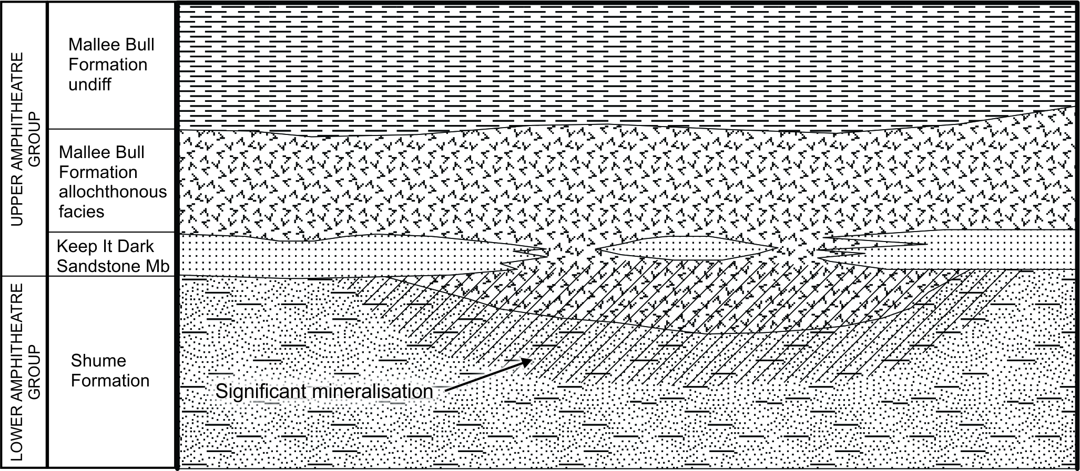
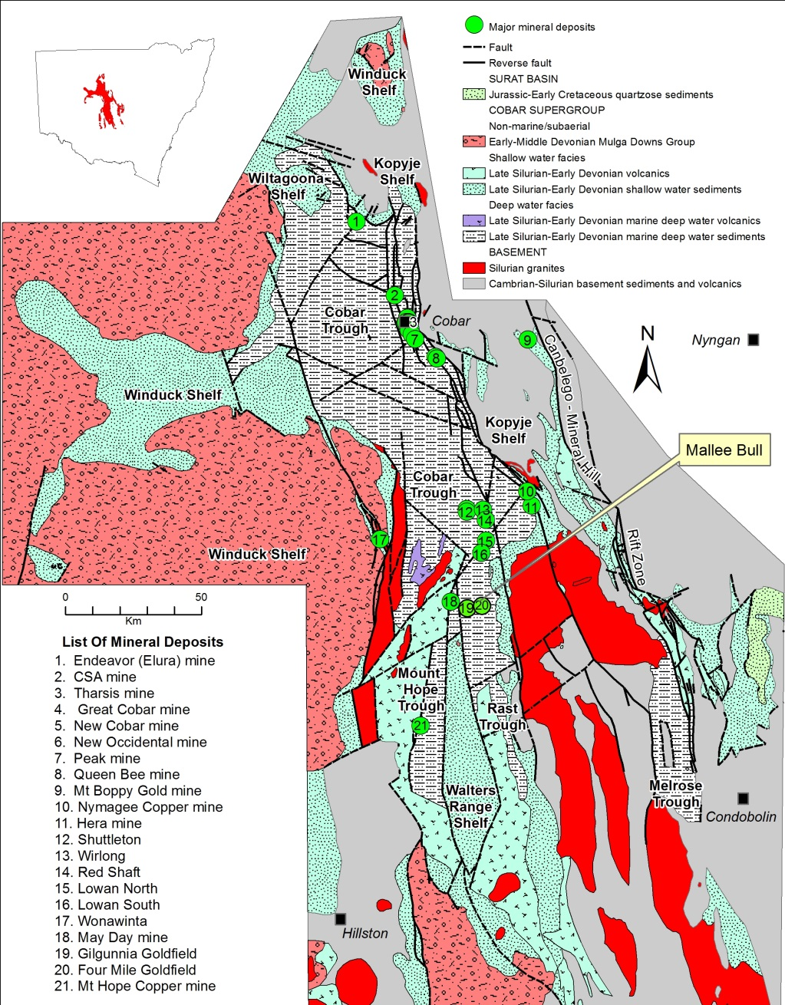
Figure 2. Stratigraphic column of the Cobar Supergroup in the Mallee Bull area. The area occupied by the Mallee Bull mineralisation is shown by hatching. Letter symbols are referred to throughout the text.
KID
MBa
Figure 1. The Cobar Basin, showing major architectural features and facies, and major mineral deposits. Compiled from NSW Geological survey data.

The Mallee Bull Deposit
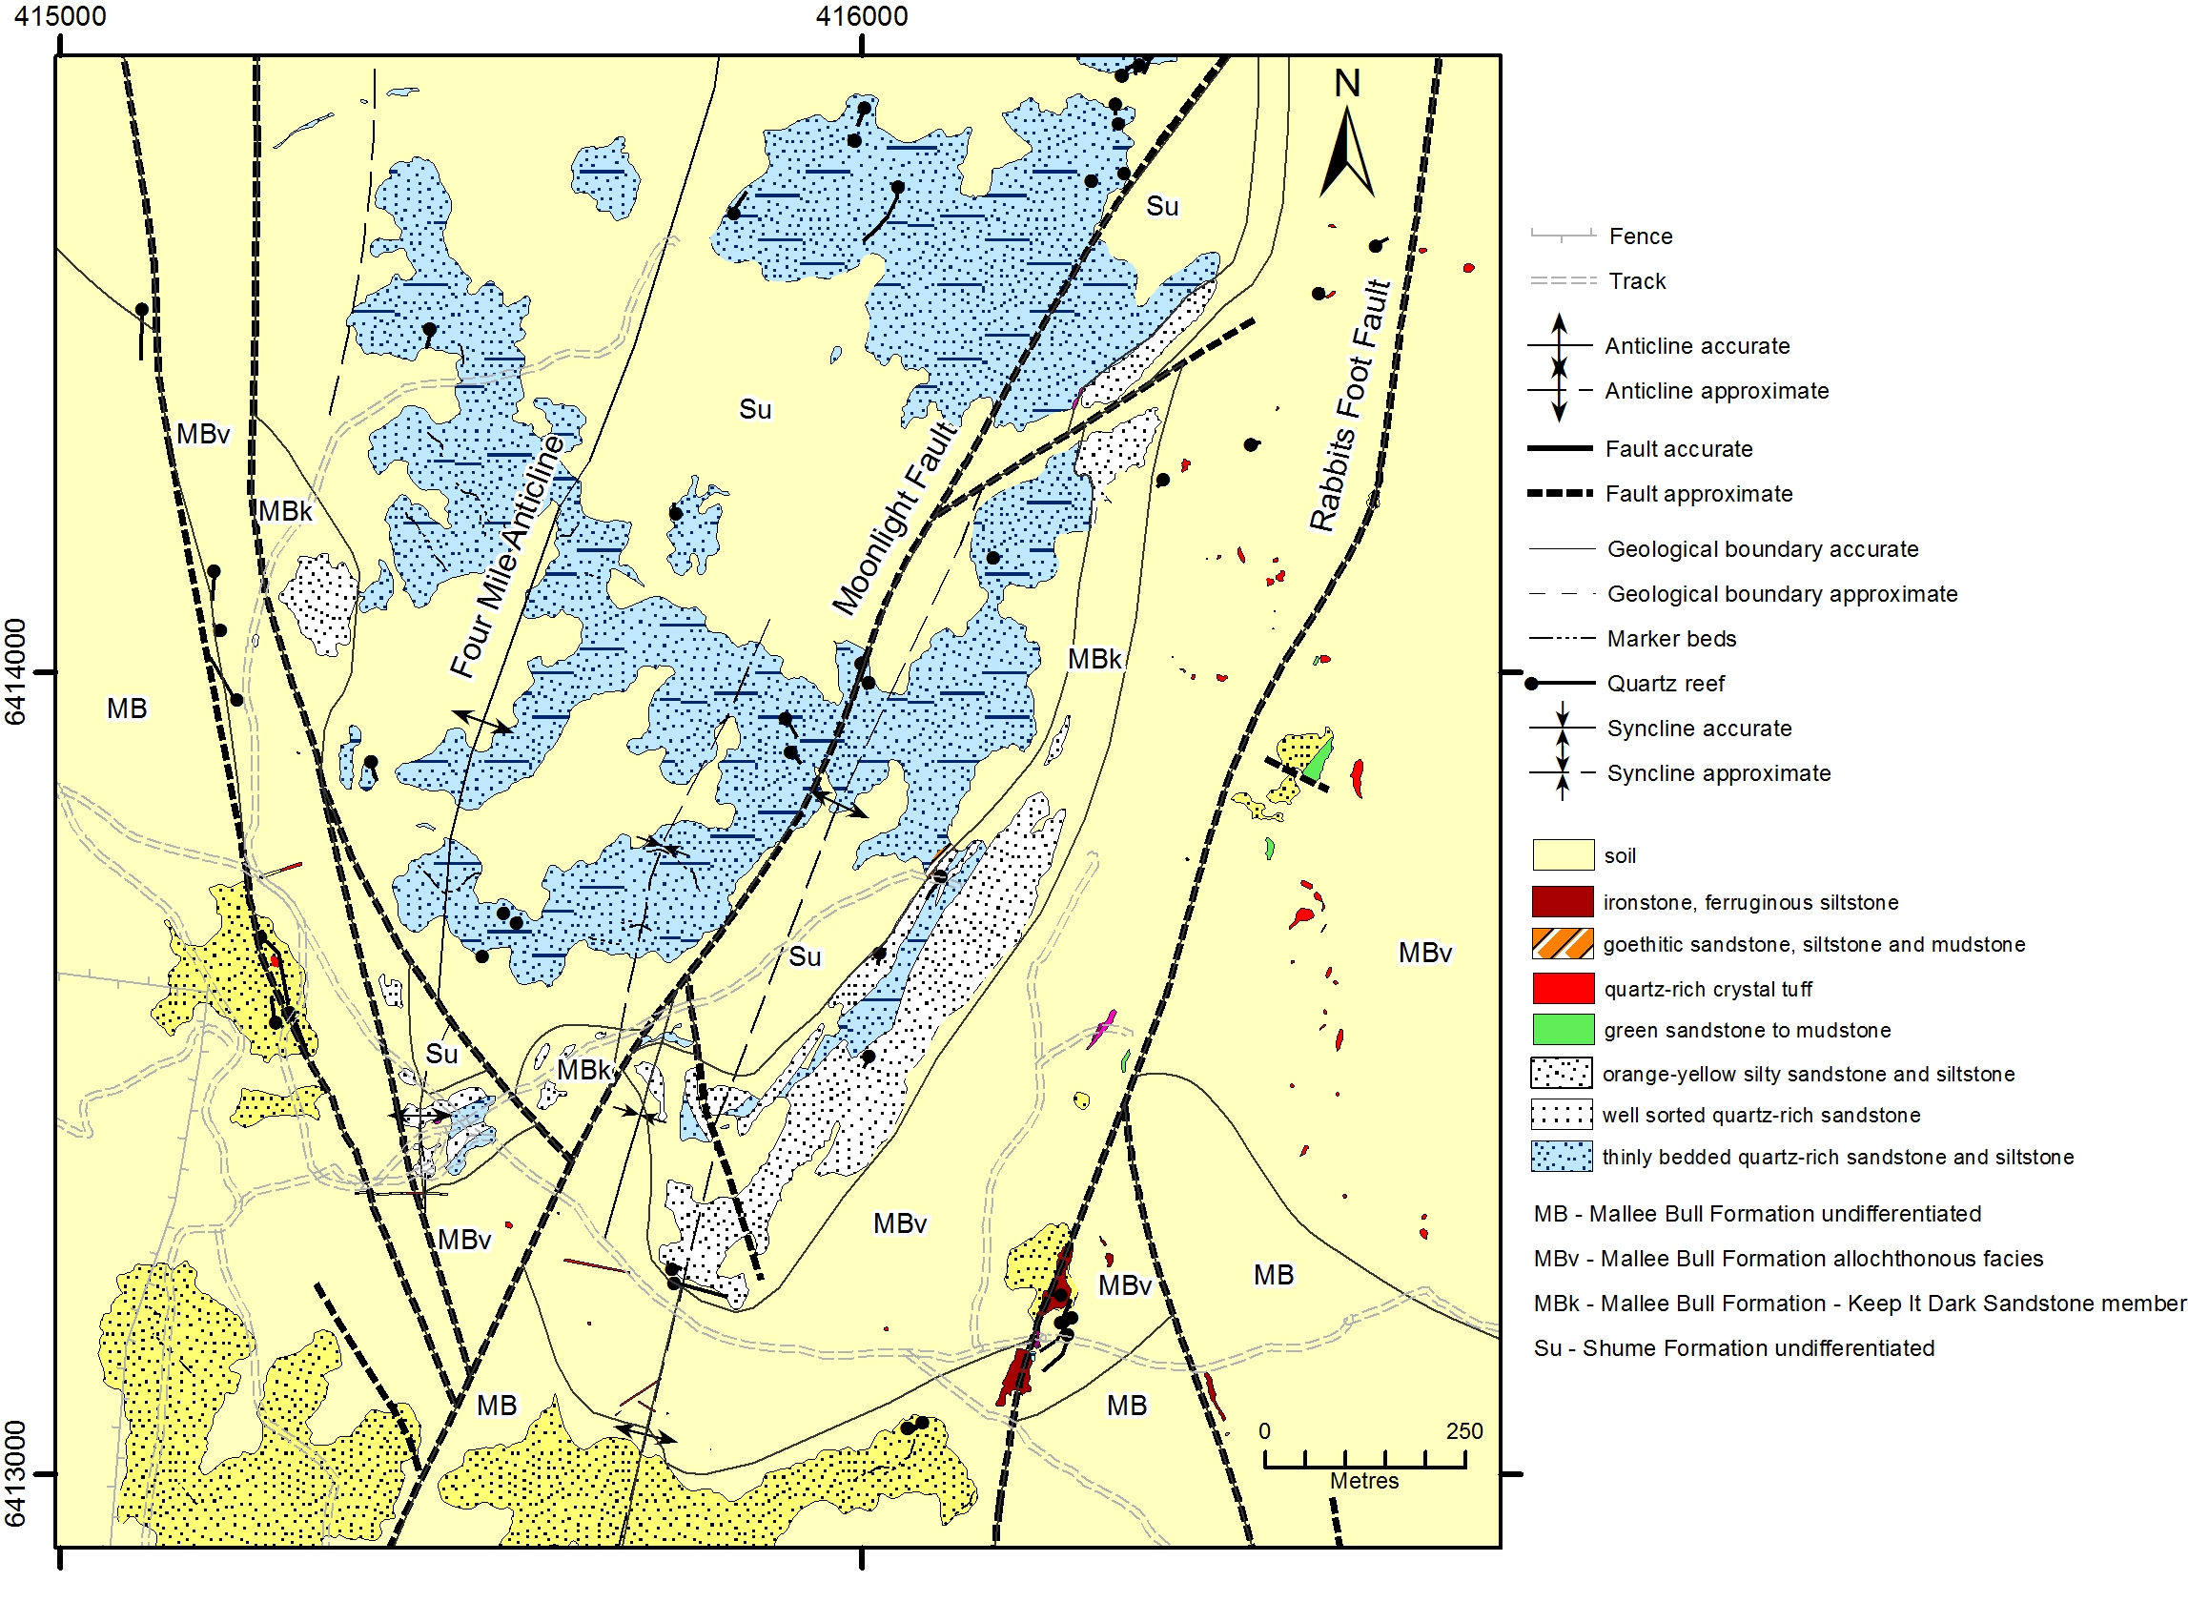
The deposit occurs close to, and on the western flank of, the nose of a south plunging anticline (Figure 3). The nose region is fractured and offset by a number of local-scale faults, and the regional-scale Moonlight Fault which is tentatively interpreted as a mineralising fluid conduit. A moderate to intense, steeply dipping slaty cleavage is axial planar to the anticline. This cleavage is most strongly manifest within argillaceous lithologies. An earlier, weak foliation is developed in argillaceous lithologies at a moderate angle to the main cleavage.
Figure 3. Outcrop geology and stratigraphic boundaries of the Mallee Bull area.
Mallee Bull deposit
Mineralisation within the Mallee Bull deposit extends from about 70 m below the surface, and is currently proven to a vertical depth of more than 800 m (Figure 4). It exhibits an elongate sheet-like geometry, dipping westward from 55° near-surface to 75° at depth in a well constrained stratabound form. The deposit is characterised by a north-south width of approximately 370 m. The stratabound relationships of mineralisation are illustrated in Figures 2 and 4. The KID marks the top of the most intense mineralisation, overlying the top of the massive sulphide lenses and replacement-style Zn-Pb dissemination zones by centimetres to a few metres.
An envelope of disseminated magnetic pyrrhotite is present for up to tens of metres above the KID within the allochthonous strata, with very minor to rare disseminated and vein-fill Zn and Pb sulphides locally.
Mallee Bull mineralisation comprises an upper series of massive to semi-massive sulphide lenses ranging from 0 to 16 m thick. In the central and lower parts of the orebody, these are dominated by a massive to deformed aggregate of fine to coarse-grained pyrite, with local replacement textures after sedimentary clasts and bedforms. Magnetic pyrrhotite is present, and toward the central and lower margins of the deposit, it is volumetrically dominant over pyrite. Minor chalcopyrite, fine-grained arsenopyrite, sphalerite and galena are present. By contrast, in the near-surface parts of Mallee Bull the massive sulphides are dominated by sphalerite and galena, with little or no pyrrhotite. Gold is present in the massive sulphides as electrum and aurostibite (Paterson, 2013) and possibly as “invisible” gold in arsenopyrite.
Within the mineralised shell, the massive sulphide lenses pass laterally into disseminated sphalerite-galena with lesser chalcopyrite, pyrrhotite and pyrite. These sulphides exhibit prominent clast replacement textures, with sphalerite and pyrrhotite partially to totally replacing granule to cobble-size clasts of original siltstone or fine-grained sandstone. In places, sulphide-rich pressure shadows are developed on the ends of elongate clasts.
An interval devoid of mineralisation is commonly present beneath the massive sulphide or disseminated sulphide zone. This interval ranges from about 1 m to tens of metres thick. The rocks in this interval exhibit strong Fe-chlorite alteration, and very rare disseminated pyrrhotite.
Throughout most of the deposit a chalcopyrite-pyrrhotite stringer zone is ubiquitous beneath the barren zone. In the uppermost parts of Mallee Bull the stringer zone is dominated by sphalerite and galena with minor chalcopyrite. The width and length of the stringer zone is similar to the overlying mineralisation. The stringer zone is about 20 - 90 m thick. It comprises a network of abundant thin to thick quartz-chalcopyrite-lesser pyrrhotite veins and quartz-healed wallrock breccia zones, with local vein-like masses of laminated to massive, remobilised chalcopyrite-pyrrhotite. Minor to abundant galena, sphalerite, euhedral arsenopyrite, and rare boulangerite, and microcrystalline cassiterite (Chapman, 2012), bismuth and bismuthinite are also present. Anomalous gold is present in some breccia zones and in addition to occurring in electrum, might also be held “invisibly” in arsenopyrite. The top and base of the stringer zone diminishes in vein intensity into adjacent host rocks. The lower extent of the stringer zone is commonly a much broader gradation into unmineralised and unaltered strata than the upper surface of this zone.
Figure 4. Cross sectional 3D view of the Mallee Bull deposit, viewed south showing drill hole traces.
Stringer zone base
Massive sulphides base
KID base
Alteration associated with the Mallee Bull mineralisation includes sulphide replacement in the polymetallic disseminated zone and massive sulphide lenses, sericitic and chloritic alteration of volcaniclastic detritus, and abundant pale green, Mg-chlorite alteration of host rocks in the stringer zone. Minor Fe-rich chlorite alteration is present locally throughout the disseminated polymetallic sulphide zone (Chapman, 2012). Disseminated, spotty pyrrhotite shows partial replacement of bedding features, and possible replacement of cleavage-aligned detritus. Silicification is intense within the polymetallic dissemination zone and in parts of some massive sulphide lenses and the stringer zone. Silica induration and alteration of siltstone and mudstone has formed pale, hard, chert-like lithologies in the upper parts of the mineralised zone, which are locally referred to in the Cobar region as “elvan” (Robertson & Taylor, 1987).

Recent Exploration
Brown et.al (2013) reported on the discovery and exploration history of Mallee Bull. Exploration and drill targeting had relied heavily upon airborne and down-hole EM with limited success from IP and gravity survey data. Since 2013 there has been substantial additional activity. From August 2013 to March 2014 an additional 15,451 metres of diamond and RAB drilling was undertaken, intercepting strong copper mineralisation at depth and extending mineralisation to more than 800m below surface. This activity included a resource definition drilling program that resulted in the maiden resource estimate for Mallee Bull released in May 2014 (Table 1). This estimate does not include Pb and Zn which are known to occur in significant amounts throughout the deposit. Following the resource estimate, a scoping study was undertaken and completed by the end of September 2014, demonstrating the need to increase the resource size of Mallee Bull to attain viability.
Cut off  CuEq % | Category | Kt | Grade |  |  |  | Contained Metal
Cut off  CuEq % | Category | Kt | CuEq | Cu % | Ag g/t | Au g/t | Cu Eq Kt | Cu Kt | Ag koz | Au koz
1.0 | Indicated | 620 | 2.22 | 1.73 | 29.0 | 0.54 | 14 | 10.7 | 578 | 11
 | Inferred | 3,300 | 2.8 | 2.4 | 32 | 0.3 | 93 | 79 | 3,395 | 32
 | Total | 3,920 | 2.7 | 2.3 | 32 | 0.3 | 107 | 90 | 3,973 | 43

Table 1. Mallee Bull maiden mineral resource estimate based on 1% copper equivalent (Cu Eq) cut-off grade. Table and supporting documentation from Peel Mining website: Resource Estimate.

In early 2015 Orion 3D DC-IP-MT and high resolution aeromagnetic surveys were commissioned in an attempt to identify hitherto unidentified mineralisation at Mallee Bull. Orion 3D is a cutting-edge geophysical system that acquires three sets of data in multiple directions – DC (direct current), IP (induced polarisation) and MT (magnetotellurics) – providing a high-resolution and deep-penetrating three dimensional survey. The Orion survey identified numerous anomalies including a large chargeability anomaly corresponding to the richest Cu mineralisation at depth in Mallee Bull, and the “T1 area” located about 150m below surface and up-dip to the east of the identified Mallee Bull mineralisation (Figure 5). T1 was defined by a very strong chargeable and corresponding low resistivity response, plus a previous gravity anomaly. A follow-up 23 hole RC drilling program totalling 4254 metres at T1 in May 2015 encountered extremely high grade Zn-Pb-Ag-Au mineralisation, open in all directions, with some of the best intercepts including:
Stringer zone base
Massive sulphides base
Figure 5. Cross sectional 3D view of the Mallee Bull deposit, viewed north showing Orion 3D IP chargeability 50 mrads shells.
T1 anomaly
- 10m @ 15.8% Zn, 7.6% Pb, 322 g/t Ag and 1.28 g/t Au from 106m in MBRC018
- 6m @ 10.30% Zn, 4.98% Pb, 159 g/t Ag, 0.76 g/t Au from 95m in MBRC021
- 12m @ 20.30% Zn, 14.81% Pb, 308 g/t Ag, 1.59 g/t Au from 83m including 7m @ 31.44% Zn, 19.37% Pb, 440 g/t Ag, 2.53 g/t Au from 83m in MBRC024
- 7m @ 21.39% Zn, 12.74% Pb, 203 g/t Ag, 0.58 g/t Au from 71m including 5m @ 29.54% Zn, 17.52% Pb, 280 g/t Ag, 0.80 g/t Au from 71m in MBRC028
Significantly, this mineralisation had not been identified using previous IP or EM methods. The Pb-Zn rich mineralisation takes the same form as the deeper parts of Mallee Bull, with upper massive sulphides passing laterally into a disseminated zone, then decreasing in abundance downward before increasing within a Pb-Zn dominant stringer zone. The mineralisation and T1 anomaly remain open to the north and south.

As a result of the significant discovery at T1 it is proposed to undertake additional drilling to further explore this relatively shallow anomalous zone. A high resolution, deep ground penetrating radar survey is also planned for the near future to provide additional lithological and structural data on the mineralisation in T1.
Other recent exploration activity has included the completion of a tenement-wide, close-spaced rock chip and soil sampling survey.

Recent Mallee Bull Research
On-going research through the University of New England has provided data relating to the detailed mineralogy, geochemistry, metamorphism and sedimentology of Mallee Bull. Geological mapping for Peel Mining Ltd and examination of drill core and chips in their tenements about the following felsic volcanic-associated prospects has provided analogies for the Mallee Bull deposit (Figure 1):
- Mayday mine,
- Red Shaft,
- Wirlong,
- Sandy Creek (8.5 km southwest of Red Shaft) and
In addition, previous exploration and research at Shuttleton (Figure 1) has been incorporated into the regional study.

Sedimentology
Logging and sampling of core and chips from the Mallee Bull area and surface outcrop mapping has yielded valuable data on the characteristics of the strata hosting Mallee Bull. This work has confirmed the stratabound geometry of Mallee Bull within a package of mass flows of felsic volcaniclastic, limey bioclastic, quartzose sandstone and intraformation diamictite compositions. These mass flow rocks comprise thin to very thick lenses and poorly stratified masses up to a total true thickness of nearly 500 m. They represent multiple pulses of mass flow debris mainly derived from the western eruptive centres near Gilgunnia (Simpson, 2014; Downes & Tilley, 2015). The sandstone-dominant KID represents a temporarily dominant influx of quartzose detritus from the eastern shelf where material for the earlier turbiditic Shume Formation and shelf-style Roset Sandstone (which crops out to the east of the Mallee Bull area) were derived (Macrae 1987). Geochemical data (see below) confirms that both the eastern and western provinces continually contributed to the mass flow deposits which were largely dominated by material from the west.
The rare, isolated presence of a tongue of mass flow strata below the KID within the Mallee Bull deposit has apparently played a critical role in focussing mineralising fluids derived from regional-scale faults spatially associated with the deposit. The fine-grained KID has apparently acted as a low permeability cap from the early stages of fluid activity, mainly transmitting early disseminated pyrrhotite into overlying volcaniclastic rocks.
The mass flow, volcaniclastic-rich strata occur at the base of the Upper Amphitheatre Group and overlie the Shume Formation. Rocks similar to this occur in an identical stratigraphic position at Wirlong-Red Shaft, Shuttleton and Mayday. This stratigraphic level marks the break between the early syn-rift phase and subsequent post-rift regimes of the Cobar Basin (Glen, 1987; 1990). The thick and regionally extensive mass flow package records a major period of seismicity accompanying changes to basin morphology. This is manifest by:
- An end regionally to the syn-rift high energy turbiditic regime (Shume Formation) which at Mallee Bull was sourced from a single provenance (see below) and
- The regional commencement of a low energy turbiditic regime (Upper Amphitheatre Group) that at Mallee Bull was sourced from two provenances.

Petrography of host rocks
Petrographic observations of the rocks that immediately host sulphide mineralisation at Mallee Bull show that there is a range of clastic sedimentary types, and local coarse felsic volcaniclastic types. Where primary textures are better preserved, it is apparent that the sedimentary rocks include matrix- and locally grain-supported, fine to medium grained sandstone (typically quartz-dominant, but with minor feldspar, lithic and muscovite detrital grains along with characteristic tourmaline and zircon), with these grading into, or intercalated with finer grained quartz-rich siltstone and with finer grained matrix-supported siltstone and mudstone that are locally carbonaceous and could have contained framboidal pyrite. Soft sediment deformation characteristics are locally observed including formation of intraclasts. Matrix material dominates siltstone and mudstone and away from strong alteration tends to be sericite-rich. Volcaniclastic rocks are typically crystal-vitric (-lithic) tuffs and/or epiclastics, broadly of dacitic bulk composition. Feldspar (plagioclase > K-feldspar), quartz and locally, biotite, would have been the main crystal components, representing former volcanic phenocrysts. Matrix material appears to have been dominated by fine grained vitriclasts. Away from strong alteration associated with mineralisation, it is apparent that the host rocks have sustained low grade metamorphism and variable penetrative deformation effects. The typical metamorphic assemblages in the rocks are fine grained and commonly dominated by sericite and quartz, with generally minor chlorite and carbonate, albitic plagioclase in the felsic volcaniclastic rocks, and traces of ilmenite, rutile and pyrrhotite. Development of minor metamorphic biotite is characteristic and implies that metamorphism attained biotite grade (i.e. middle greenschist facies). Deformation appears to have been coeval with metamorphism and is indicated by development of a foliation defined by preferred orientation of layer silicates and pyrrhotite aggregates. Foliation is typically better developed in finer grained rocks, including the matrix of volcaniclastics. Deformed, syn-tectonic veining is commonly present, generally quartz-dominant, but also containing phases including carbonate, chlorite and sulphides.

Hydrothermal alteration
Strong hydrothermal alteration and replacement of the host rocks has occurred in association with sulphide mineralisation and these phenomena are accompanied by emplacement of scattered syn-tectonic veins and hydrothermal breccia zones. The latter range from clast- to matrix-supported and contain altered host rock fragments, with infill of breccia zones and veins typically dominated by strained and recrystallised (locally fibre-texture) quartz, sulphides, carbonate and chlorite. Minor phases observed include albite, K-feldspar, stilpnomelane, magnetite and biotite. There are two main types of hydrothermal alteration of host rocks, with these grading into one another and locally merging into a minor type. There does not appear to be a consistent association between alteration and mineralisation types. A common type of alteration, found mostly in sandstone and siltstone, is chloritisation, in places accompanied by minor to abundant quartz, pyrrhotite and other sulphides, carbonate, sericite, biotite, stilpnomelane, magnetite and ilmenite. With increasing content of fine grained quartz, this type of alteration can grade into silicification, characteristic of “elvan” (altered fine grained siltstone). The other common type of alteration, found in all types of clastic sedimentary host rocks and in felsic volcaniclastics, is sericitisation. This can also be accompanied by pyrrhotite and other sulphides, porphyroblastic carbonate, chlorite, biotite, tourmaline and trace rutile. It is evident locally that alteration, especially chloritisation, required mobility and loss of components, e.g. SiO₂, that there was substantial mobility of Mg, Ca, K and Na, and hydrothermal addition of minor to abundant S, Fe, base metals, As, Sb, Ag, Bi and CO₂.

Ore mineralogy
Sulphide mineralisation at Mallee Bull ranges from massive to disseminated and stringer vein types, including zones of apparent hydrothermal breccia development. Sulphide textures indicate a range from replacement of altered host rock through to a minor to major infill component of veins and breccia zones. No convincing textures have been recognised indicating early, syn-sedimentary base metal sulphide deposition or syn-diagenetic replacement of the host rocks. Massive sulphides and associated peripheral more disseminated zones fall into two main types – ZnPb-rich and pyritic. The ZnPb-rich sulphides are dominated by sphalerite (low-medium Fe content), galena and pyrrhotite, commonly with a little chalcopyrite and traces of pyrite, arsenopyrite, tetrahedrite and boulangerite. This type of mineralisation is typical of the newly-located T1 zone. There are evident gradations into sulphide-rich rocks containing higher proportions of pyrite, and of chalcopyrite. The pyritic massive sulphides are dominated by inequigranular recrystallised pyrite, with variable amounts of pyrrhotite and chalcopyrite, and generally trace amounts of sphalerite, galena and Bi minerals (bismuth and bismuthinite). The stringer zone mineralisation commonly contains abundant pyrrhotite and chalcopyrite, in places with considerable sphalerite and pyrite, locally common arsenopyrite and galena, and minor to trace amounts of phases that include magnetite, cassiterite, boulangerite, bismuth, bismuthinite and breithauptite. Although there is little indication of supergene alteration, many samples from relatively shallow depth (e.g. in the T1 zone) show that pyrrhotite has been replaced by secondary pyrite ± marcasite, and there is also minor goethite-rich gossan material at T1 (rich in Ag and Pb) that contains trace particulate gold.
Throughout the sulphide mineralisation, it is evident that sulphide minerals show strain, fracturing and recrystallisation textures consistent with the deformation fabric in the host rocks, and with deformation characteristics in gangue phases such as quartz and carbonate in veins and hydrothermal breccia masses. Throughout the sulphide-rich rocks, there is a consistent picture of early-crystallised pyrite and arsenopyrite (± magnetite), with subsequently deposited pyrrhotite and/or sphalerite, apparently followed by chalcopyrite and galena. Boulangerite and tetrahedrite tend to be mostly associated with galena and sphalerite, whereas bismuth and bismuthinite are more commonly associated with chalcopyrite and pyrrhotite.
The mineralogical observations on sulphide-rich rocks, together with multi-element geochemical data, provide insights into the metal deportment. It is obvious that most Cu is hosted in chalcopyrite, Zn in sphalerite and Pb in galena. Boulangerite and tetrahedrite are likely to be the main hosts for Sb and probably, Ag, and the Bi minerals and cassiterite are obviously the main repositories for Bi and Sn, respectively. Arsenopyrite probably hosts most As, although some As might also occur in pyrite, and it is speculated that in the absence of significant particulate gold or electrum, that at least some of the Au assay values occur “invisibly”, i.e. chemically held in arsenopyrite. Elevated Co values could be largely held in pyrite, although there is a possibility that traces of cobaltite could occur in stringer zone material.

Geochemistry
Target, pathfinder and mobile elements display subtle to clear relationships in the Mallee Bull orebody. Mineralisation styles based upon drillhole logging include massive sulphide, disseminated sulphide and stringer style mineralisation. These distinctions have been used to elucidate key geochemical characteristics of the deposit using available data.
Key elements enriched in the primary dispersion halo associated with mineralisation include Cu, Pb, Zn, Ag, As, Au, Bi, Sb, Sn and Co. Element distribution reflects the complex ore mineralogy, indicating broad zonation and possible multiple fluid events. There is a moderately well defined vertical metal zonation from Pb-Zn-Ag-rich massive sulphide mineralisation at the top of the system to a Cu-rich stringer zone at depth. Overall, there are strong positive correlations between Cu and Ag, Bi and Co, Bi and Cu, Sb and Ag, Co and Au and Zn and Pb. Cu and Pb and Cu and Zn correlate poorly, except in individual drillhole data. In massive sulphide zones there is strong positive correlation between Bi and Cu, Cu and Ag with Zn and Pb. In the stringer zone significant correlation exists between Ag and Cu, Pb and Zn and Bi and Cu. Whilst Au and As are significantly enriched, they correlate poorly with other metals in the different mineralisation zones and do not show a consistent relationship with depth.
Preliminary examination of major and trace element data indicate that Fe and S are strongly enriched in mineralised horizons, reporting into the dominant sulphide minerals. Element depletions are variable and include Na, K, Ba, Ca, Sr, P and Mg the most affected, particularly in the massive sulphide mineralisation. In the stringer zone and disseminated sulphide mineralisation, Na is weakly enriched and has weak positive correlations with target and pathfinder elements, whilst Ba, K and Ca are depleted. In the stringer zone and in disseminated sulphide horizons K is variably enriched over Ca and Na in some drillholes. The complex behaviour of elements is due to their partial retention after primary mineral breakdown in hydrothermal minerals such as albite (Na), sericite (K), calcite (Ca) and chlorite (Mg). The apparent depletion of elements such as K, P, Ca and Mg may be due in part to strong enrichment of Fe and S and base metals. Ti/Al ratios indicate relative immobility except in the massive sulphide mineralisation.

DEPOSIT | COMMODITIES | HOST ROCKS | RELATIONSHIPS
Mallee Bull | Cu-Pb-Zn-Ag-Au | Coarse, pebbly volcaniclastics, quartz-rich turbidites, base of Upper Amphitheatre Gp | Stratabound, local regional-scale faults, flank of anticlinal crest. Mineralisation in volcaniclastics and turbidites.
Mayday | Zn-Pb-Cu-Ag-Au | Coarse, pebbly volcaniclastics and interbedded sediments, base of Upper Amphitheatre Group | Stratabound, steeply plunging mineralised shoots of sulphides within volcaniclastics and sediments. Adjacent to regional-scale structural corridor.
Wirlong | Cu-Zn-Pb-Ag | Coarse felsic volcaniclastics and adjacent fine-grained turbidites, base of Upper Amphitheatre Group | Stratabound within regional-scale, fault-bounded corridor of tightly synclinorially-folded volcanics and turbidites. Mineralisation in both volcaniclastics and turbidites
Red Shaft | Pb-Zn-Cu-Au | Coarse volcaniclastics and adjacent fine-grained turbidites, base of Upper Amphitheatre Group | Mineralisation within sediments along contact with tightly folded volcanics. Nearby regional-scale faulting.
Sandy Creek | Pb-Zn-Cu-Ag | Fine-grained turbidites with local lenses of coarse-grained felsic volcaniclastics; base of Shume Formation | Mineralisation stratabound parallel to local regional-scale faults and fold axes.
Shuttleton | Cu-Pb-Zn-Ag | Felsic volcaniclastics interbedded with sediments, base of Upper Amphitheatre Group | Mineralisation within both volcanics and adjacent sediments but strongest in volcanics. Adjacent regional-scale fault.
Table 2. Characteristics of some analogous mineralisation within the southern Cobar Basin.

DEPOSIT | COMMODITIES | HOST ROCKS | RELATIONSHIPS AND MINERALISATION CONTROLS
Mallee Bull | Cu-Pb-Zn-Ag-Au | Coarse, pebbly volcaniclastics and minor limestones (basal Upper Amphitheatre Group), quartz-rich turbidites (Shume Fm). | Stratabound in mass flow rocks and adjacent turbidites, within hundreds of metres of regional-scale faults, flank of shallowly-plunging anticlinal crest. Tabular orebody dips 50-80º for about 700 m. Low-medium strain.
Elura/Endeavor | Pb, Zn, Ag | Turbidites (CSA Siltstone) | Orebodies vertical for about 1000 m, fault-bound lobes, truncated by dip-slip faults. Low-medium strain. Above growth fault and adjacent to regional transform fault.
CSA | Cu, Pb, Zn, Ag | Turbidites (CSA Siltstone) | Vertical, en-echelon, podiform lenses continuous for about 2000 m within steep east-dipping shear zones in hinge of monocline adjacent to transform and growth faults. High strain.
Great Cobar | Cu, Au | Turbidites (Great Cobar Slate) | Lenses within steeply east-dipping shear in hinge of steeply-plunging anticline adjacent to transform fault. High strain.
New Cobar | Cu-Au | Turbidites (Great Cobar Slate) | Steep lenses to about 700 m deep within east-dipping splay fault associated with a jog in the Great Chesney fault. High strain.
Peak | Au, Cu, Pb, Zn, Ag | Fault-bounded rhyolite blocks within turbidites of the Chesney Formation near its contact with the Great Cobar Slate | Podiform lenses in dilational zones within the steeply dipping Peak Shear above and around competency contrasting rhyolite blocks. High to extreme strain.
New Occidental | Au (Pb-Zn) | Contact between turbidites of Chesney Formation and Great Cobar Slate | Subvertical to vertical, disc-like lenses to about 1200 m deep within a dilational jog in the steep east-dipping Great Chesney fault. High strain.
Nymagee-Hera | Au, Cu, Pb, Zn (Ag) | Turbidites of Mouramba Group adjacent to Lower Amphitheatre Group. Rhyolite near mineralisation. | Steeply dipping lenses to 250 m deep in splay of Rookery Fault, associated with steeply plunging isoclinal folds. High strain.
Table 3. Selected characteristics of major deposits in the eastern Cobar Basin compared with the allee Bull deposit. Data from Suppel & Gilligan (1993), Stegman (2001), David (2005).

Regional Analogies and Contrasts
Outcrop mapping, drill hole data and local and regional-scale geophysical interpretation have shown strong similarities between the geological and structural setting of Mallee Bull and a number of other deposits in the southern, central Cobar Basin. These are summarised in Table 2. The Mallee Bull deposit shares similar chemistry, mineralogy and textures, but contrasting controls and deposit geometry with many of the large Cobar-style deposits developed along the eastern margin of the Cobar Basin (Table 3). In general comparison with the eastern basin deposits, the Mallee Bull deposit is in a lower strain zone, is lithologically rather than fault- or shear-controlled, is only subvertically-dipping at depth with moderate dips near-surface and is largely hosted by mass flow volcaniclastics rather than turbidites.

Fluid Source Characteristics
The shared similarities of the southern-central Cobar Basin deposits (Table 2) relate to the essential presence of unwelded, permeable felsic volcaniclastics, and regional-scale, north to northeast-trending faults. The proposed genetic model for Mallee Bull is syn-tectonic, with mineralisation emplaced during the early stages of the final basin inversion event. Recent stable isotope interpretations from Downes & Tilley (2015) suggest that S-isotopes were derived dominantly from basinal fluids. Pb-isotope data by the same authors suggests a basement origin for Pb-isotopes, which would potentially imply derivation from older basinal sediments derived from reworking of Ordovician basement rocks. Interpretation of the isotopic results suggests that Mallee Bull was derived from orogenic fluids circulating through the older Cobar Basin sedimentary pile. These fluids were focused into major fault planes during inversion after which the fluids passed into porous felsic volcaniclastic aquifers, with concentration beneath an impermeable cap rock at Mallee Bull.
Shuttleton shares similar S-isotope sources as Mallee Bull and a mid-late Silurian-dominant Pb-isotopic signature. This is interpreted to represent a similar genesis as Mallee Bull, but with source fluids derived from detritus shed from the volcanic provenance producing the Mount Hope Group. Suppel & Gilligan (1993) discussed two potential origins for the Shuttleton mineralisation:
- epigenetic, with fluids emplaced along a major fault during deformation, and
- syngenetic, emplaced contemporaneously with the host felsic volcanics; this was favoured by those authors

Acknowledgements
The authors would like to thank Peel Mining for giving permission to write this paper. Our joint venture partner CBH Resources are also thanked for co-funding the ongoing development at Mallee Bull and adding to the expertise base.

References
Brown R.E., Chapman N., and Oates M. 2013. The Mallee Bull discovery and exploration in the central Cobar Basin. In Lewis P.C. 2013, Mines and Wines 2013, AIG Bulletin 55; 5-12.
Chapman N.D. 2012. Characteristics of the mineralisation of the Mallee Bull Prospect, Cobar District, Western N.S.W. B.Sc. (Hons) Thesis, University of New England, Armidale
David, V. 2005. Structural settings of mineral deposits in the Cobar Basin. Unpublished Ph.D. Thesis, University of New England. Armidale, NSW, Australia, 286 pp.
Department of Primary Industries, 2007. Cobar's mining history. NSW Department of Primary Industries, Primefact 555.
Downes P and Tilley D, 2015. Keys to understanding the Central Lachlan — the Nymagee mineral systems(MinSys) study. Presentation to The Sydney Mineral Exploration Discussion Group, March 2015 (unpublished).

Fergusson, C.L. 2003. Ordovician-Silurian accretion tectonics of the Lachlan Fold Belt, southeastern Australia. Australian Journal of Earth Sciences, 50(4), 475-490.
Foster, D.A and Gray, D.R. 2000. Evolution and structure of the Lachlan Fold Belt (Orogen) of eastern Australia. Annual Review of Earth and Planetary Sciences, 28(1), 47-80.
Glen, R.A. 1987. Copper- and gold-rich deposits in deformed turbidites at Cobar, Australia: their structural control and hydrothermal origin. Economic Geology, 82(1), 124-140.
Glen, R.A. 1990. Formation and inversion of transtensional basins in the western part of the Lachlan Fold Belt, Australia, with emphasis on the Cobar Basin. Journal of Structural Geology, 12(5), 601-620.
Glen, R.A. 1992. Thrust, extensional and strike-slip tectonics in an evolving Palaeozoic orogen—a structural synthesis of the Lachlan Orogen of southeastern Australia. Tectonophysics 214, 341–380.
Glen, R.A. 1994. Geology of the Cobar 1:100 000 sheet 8035. Geological Survey of New South Wales, Sydney.
Glen R. A., Drummond B. J., Goleby B. R., Palmer D. & Wake-Dyster K. D. 1994. Structure of the Cobar Basin, New South Wales, based on seismic reflection profiling. Australian Journal of Earth Sciences 41, 341–352.
Lawrie, K.L., and Hinman, M.C. 1998. Cobar-style polymetallic Au–Cu–Ag–Pb–Zn deposits. AGSO Journal of Australian Geology and Geophysics, 17, 169–187.
Macrae G.P. 1987. Geology of the Nymagee 1:100 000 Sheet 8133. Geological Survey of New South Wales, Sydney.
Paterson L. 2013. Mineralogical investigation of four samples from a copper gold prospect. Job No: MY060. SGS Lakefield Oretest Pty Ltd. Unpublished report to Peel Mining Ltd.
Peel Mining Ltd. 2014. High grade copper resource at Mallee Bull. ASX/Media release, 27 May 2014.
Perkins C., Hinman M. C. and Walshe J. L. 1994. Timing of mineralization and deformation, Peak Au mine, Cobar, New South Wales. Australian Journal of Earth Sciences, 41(5), 509-522.
Robertson, I.D.M. and Taylor, G.F. 1987. Depletion haloes in fresh rocks surrounding the Cobar ore bodies, NSW, Australia: implications for exploration and ore genesis. Journal of Geochemical Exploration. 27: 77-101
Sangster D.F. 1979. Evidence of an exhalative origin for deposits of the Cobar district, New South Wales. BMR Journal o] Australian Geology & Geophysics, 4, 1979, 15-24.
Simpson C. 2014. Nymagee Project: Petrographic re-assessment of the Mount Halfway Volcanics and other formations in the Mount Hope Group. Geological Survey of New South Wales, unpublished internal report.
Stegman, C. L. 2001. Cobar deposits: Still defying classification. Society of Economic Geologists Newsletter, 44: 1, 14-26.
Suppel D.W. & Gilligan L.B. 1993. Nymagee 1:250 000 Metallogenic Map SI/55-2: Metallogenic Study and Mineral Deposit Data Sheets. 171 pp. Geological Survey of New South Wales, Sydney.

